3(ii) Option 2: Neural Networks
(a) Describe at least three differences between ALS and neural networks.
- ALS is unsupervised, which means that each data does not have a label. But neural network is supervised.
- ALS algorithm focusing on matrix factorization alternating between Z and U. But neural network moves forward to multiple layers.
- Since ALS fit Z and optimize U, followed by fit U and optimize Z, only two activation functions are used and fixed to each optimization steps. But neural network is free to choose different choices of activation functions between layers.

(d) We iterate over k=[10, 50, 100, 200, 500] for 3 times. Overall the best performance k* is 50 and it returns an accuracy of 0.6845893310753599
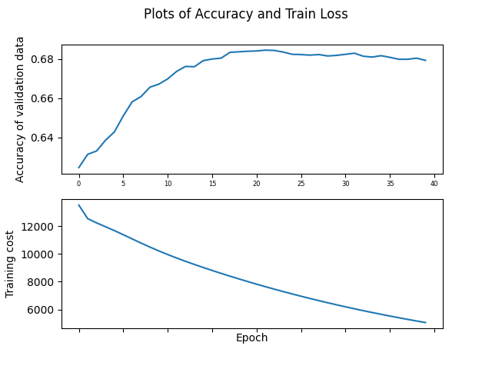

(e) After we iterate over $λ=\{0.001, 0.01, 0.1, 1\}$ for 3 times, the best performance $λ$ is 0.1. Then we plot the accuracy and the training cost again.
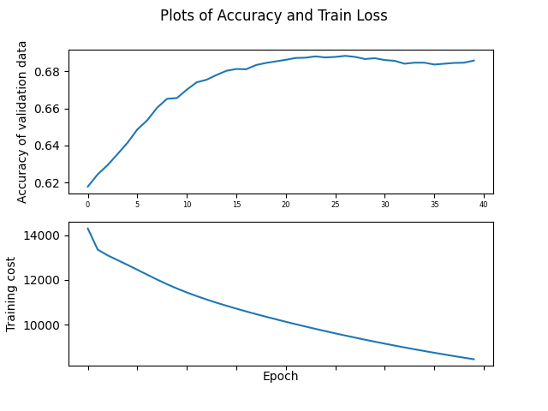
Notice that the training cost is much higher than not using the regularization. On the other hand, the accuracy does not increase but become more stable as the epoch increases instead of decreasing like part (d). We think our model performs better with the regularization penalty.

